BLOGPOST - The 7 Best Ways to gather Customer Feedback

Collecting and acting upon customer feedback is a must for any business looking to provide users with the products they need.
Customer feedback guides and informs your decision making and influences your product roadmap. It’s also essential for measuring customer satisfaction among your current customers.
Getting a handle on how customers view your product, support, and company is invaluable. Today we’re going to look at the best ways you can gather insights from current and prospective customers who visit your site.

8 ways to collect customer feedback
Before you begin collecting feedback from customers, you need to make sure you have clearly defined why you are seeking feedback.
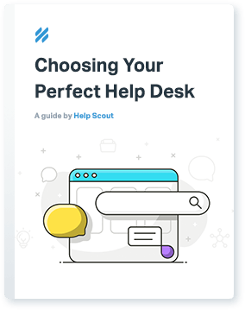

Download Your Free Guide
From your initial search to final purchase and setup, this (unbiased) resource will help make choosing any help desk easier.
Outlining the process as well as desired outcomes is essential for gathering customer feedback the smart way. Without a clear “why,” you’re asking for feedback that will only muddy your understanding of your customers.
Before you start, consider:
- What part of the customer experience do you want to improve? (Onboarding? Content marketing? Hone in on what part of the customer journey would benefit from customer insights.)
- What will you do with the data you collect? (There’s no point in gathering customer feedback if you don’t plan to follow through. If your customer survey reveals that part of your product’s UI is confusing, then you’d better be prepared to invest design/development resources to fix it.)
- Which channel for collecting customer feedback works best for your goals?
We’ll address this last question in the rest of this post — a complete breakdown of the most effective ways to gather feedback from current and prospective customers.
1. Customer feedback surveys
Crafting a useful customer survey is no easy task. There are so many potential questions you could be asking customers, but you have to be careful in your approach.
One way the web has made collecting surveys easier is to let you test a longer, more traditional survey versus a shorter, “slider” survey that appears onscreen as a customer browses your site:
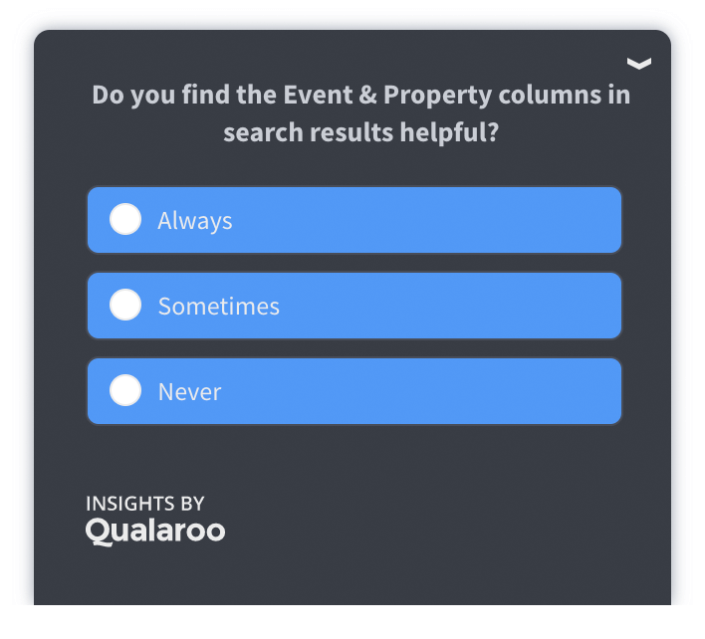
For these short surveys, you can use tools like Qualaroo (featured above) to ask a simple question or conduct a brief poll, with the goal of generating responses from customers who are active on your website.
For longer-form surveys, platforms such as Typeform, Survey Monkey, and GetFeedbackcan be customized to host any question type.
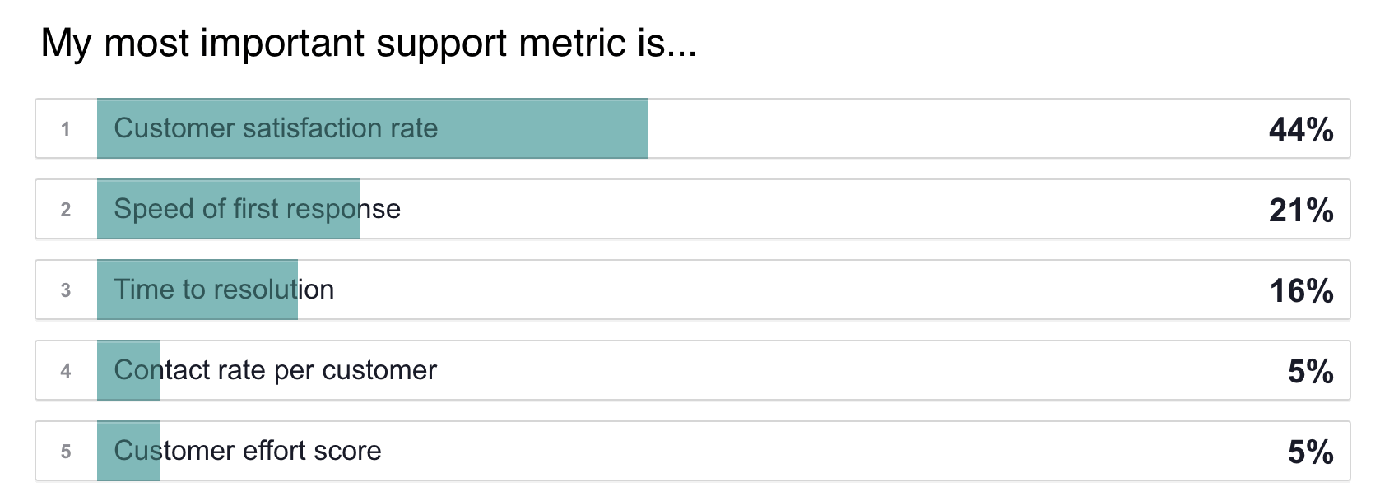
Remember that if you want to create a customer survey that works — as in, one that customers will actually complete — you need to make sure your survey follows these proven guidelines:
- Ask only questions that fulfill your end goal
- Construct smart, open-ended questions
- Ask one question at a time
- Make rating scales consistent
- Avoid leading and loaded questions
Be sure to check out our full coverage of this topic by reading this post.

2. Email and customer contact forms

Email is one of the most valuable ways to gather candid customer feedback.
However, you can improve the way customers reach out to you via email and maximize this channel’s effectiveness — all of these changes will create a better experience for customers, too.
The three main elements you should focus on for soliciting feedback via email are:
- Assuring customers of a speedy response.
- Creating an organized customer feedback system.
- Sending candid follow-up emails.

A. Setting customer expectations
Customers often don’t complain or leave feedback because they don’t think the business cares. Is it any wonder most companies don’t hear from unhappy customers? But a majority of those same customers would be willing to leave feedback if they knew they’d hear back, and when.
If you want to ensure you’re hearing candid feedback from customers, the simple addition in your email of “We’ll get back to you within X hours/days” will go a long way.

B. Keeping email feedback organized
In an earlier post covering our workflow for managing feedback, I discussed how to use tools like Trello to create “boards” your whole team can access and contribute to, ensuring that no good feedback slips through the cracks.
That post covers our method in detail, but the takeaways are:
- Create boards within Trello titled “Product Ideas” (feature requests), “Up Next” (what’s being worked on) and “Roadmap” (what you plan to work on).
- Create individual cards within each board to categorize requests. For our Product Ideas board, we use sections like “Inbox” (new ideas), “Rejected” (discarded ideas), “Someday/Maybe” (good ideas, but not urgent), and “Apps” (integration requests).
- Add email addresses within cards for the people who requested the idea. For instance, anyone who asked us for Reports upgrades will be added to a list within a card so that they can be notified when the upgrade is complete. Here’s an example card (with emails blocked out for privacy):
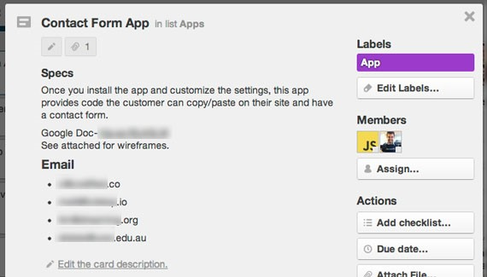
This system lets you keep tabs on what’s being requested and by whom, as well as tracking ideas you’ve already passed on. This also gives employees a clear roadmap for future customer interactions.

C. The value of a personal email
Sometimes the best way to get a candid response from a customer is to simply ask for one. Since email isn’t public (like social media) and because the method is personal (unlike a survey), it can allow you to start some pretty interesting conversations with customers.
When customers sign up via email to access information on the site, for example, you have the opportunity to send out an auto-responder email that asks a single question. You can inquire about what customers are struggling with, what feature they’d like to see the most, or simply ask why they signed up. Just make sure you actually reply to these emails, or you’ll be letting people down and they won’t want to email you again.
Another example of using email to collect customer feedback is via your help desk’s happiness Ratings. When your customers rate a reply that came from Help Scout, for instance, they see a screen like this where they can also provide additional comments:
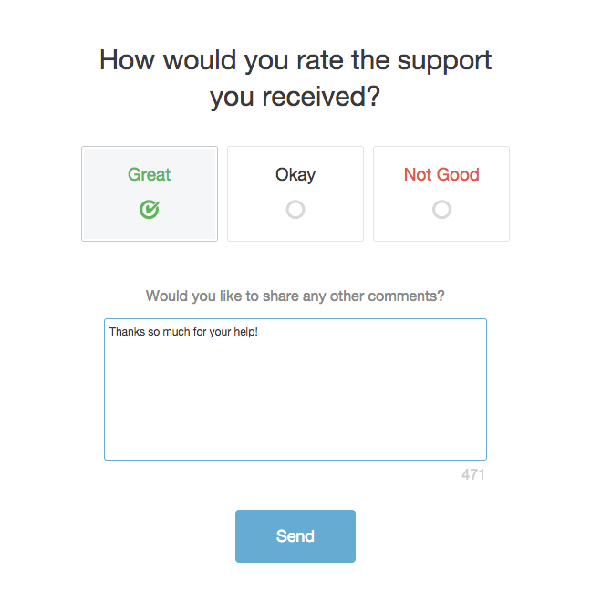
Those ratings and comments can then be easily sorted and filtered in happiness reportsthat show how teams and individual team members are performing.
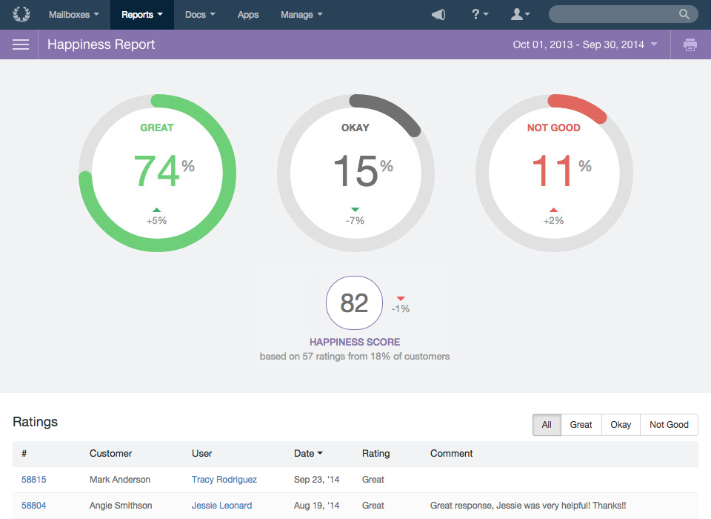
3. Usability Tests
Usability testing requires more upfront planning, but delivers more insights than any of the methods listed here. It uncovers things customers sometimes don’t know they’re thinking about or struggling with, and usually provides you with a clear path to make the experience better. Google, a longtime advocate of rapid iteration based on early and frequent user feedback, rewards its user research participants.
At Help Scout, we regularly turn to usability testing to get the design details for a specific process or feature just right. It may be 90% finished, but well-run tests guarantee that we get the final (most important) 10% right. As we prepare to launch major improvements to our Beacon product, such as live chat, for example, we’re opening Beacon 2.0 to a small number of beta participants based on their current implementation of Beacon 1.0 — and we fully expect to make adjustments to the product based on the feedback we receive.
User testing is common for websites and web-based products, but the fundamentals are applicable in any business. Let’s say you run a gym. Give a customer a free month to go to the gym 3-5 days a week and keep a diary about their experience. Seeing the business through a different lens uncovers little things that can make a huge difference.
To get started with usability testing, we highly recommend Rocket Surgery Made Easy by Steve Krug. For web-based testing with people that are unfamiliar with your business, UserTesting.com does an outstanding job.

4. Exploratory customer interviews
Can direct outreach really be beneficial in getting feedback from customers? Absolutely. Understanding your customers is often as easy as talking to them directly.
This direct outreach can also help fill in the gaps that less personal forms of feedback tend to create. For instance, as Lars Lofgren highlights in The 5 Best Ways to Get Feedback from Your Customers, if you provide an app that creates invoices, and customers have repeatedly told you that they want to customize the design, a few things could be going on here:
- Your customers are mostly designers, and this customization aspect is important for branding.
- Your current design options are lacking.
- They really only need to tweak a few minor sections.
There are a couple important things to note when conducting these sorts of interviews, and the following tips from the Nielsen group can help you get started:
- Focus on user attitudes. Explore how users think about a problem. Asking them what a button color should be will get you nowhere, but understanding their impressions (“This feature is too complicated”) will allow you to alter features to address the problem.
- Use the critical incident method. Ask users to recall specific instances in which they faced a particularly difficult usage case or when something worked particularly well.
- Inquire about habits. Asking users how they normally do a task can reveal problems they didn’t even know were there. If a user is jumping through four menus to do something that they could do with a shortcut, then you now have something to fix.
Since you can get face-to-face and share screens online with programs like Zoom and appear.in, don’t let distance stop you from having one-on-one interviews with customers.

5. Social media
Listening through social media can prove particularly useful for gathering candid feedback from customers. Direct comments or mentions on social networks aren’t the only way for your business to collect customer feedback — many social networks have polling tools built in. Consider this quick poll conducted on Facebook:
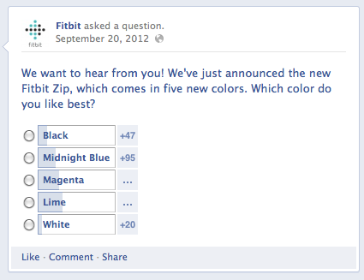
In this instance, a short poll on a highly popular social network makes plenty of sense; it’s too short to include as a separate survey, and asking this question on-site would distract from far more important goals.

6. On-site activity (via analytics)
What are your users telling you without telling you?
Sometimes the best feedback is found when users are candidly using your product (and not being asked how they use it). To get a peek at these sorts of insights, you can turn to analytics that showcase how users are interacting with your site.
For example, let’s say you are using content as a form of customer service. You might see that thousands of people are visiting your content to get their questions answered. But have you looked at how they are using it?
If your FAQ section has a 0:09 average on-page time and an awful bounce rate, you know something isn’t being communicated clearly. People are visiting your support content but obviously not utilizing it. Reporting tools like Help Scout’s Docs Report can give you insights about failed searches, which pages are most often visited, and so on, giving you the opportunity to improve your customer’s self-service experience.
In other instances, you might want to track how users who did not sign up for your product behaved. Brennan Dunn, founder of Planscope, discovered a weakness on his site by using the analytics tool KISSmetrics:
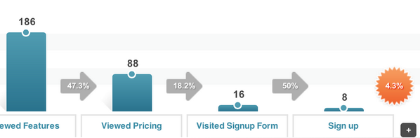
Without on-site data like this, it’s unlikely a user would come forward and explain why they abandoned the site (after clicking through on other pages). It’s sometimes necessary to see how people view your site when they don’t know anyone is watching.

7. Comment boxes
Speaking of KISSmetrics, one of the more creative ways we’ve seen for measuring user satisfaction with a particular page can be found in how they implement feedback boxes at the bottom of particular pages.
KISSmetrics product manager Jason Evanish says pop-ups and live chats often interrupt the flow of whatever a customer was doing (and live chats require an employee around).
Instead, he’s found that strategically inserted comment boxes at the end of pages draw candid feedback that doesn’t require employee monitoring or interrupt a user while they’re browsing the page:
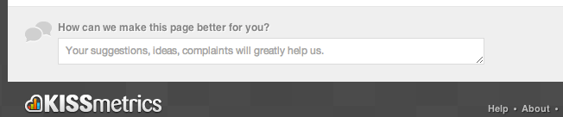
Source: KISSmetrics.
For technical details (and an extensive overview) of how to implement these boxes, read this post by Evanish on the KISSmetrics blog.

8. Instant feedback from your website
With an an embeddable on-site widget like Beacon, you can collect instant customer feedback without the customer having to answer any questions.
For instance, we recently designated nine articles that we thought might be valuable to anyone who had questions after visiting a certain page on our website.
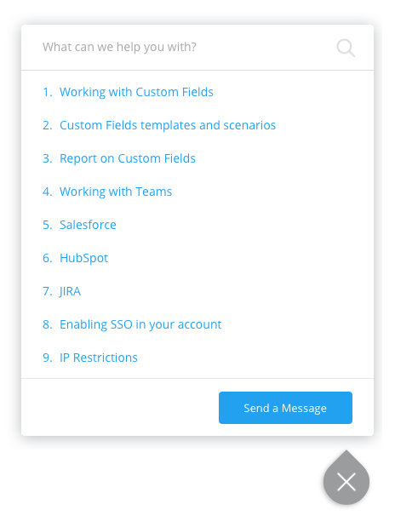
Beacon then collects insight into which articles people click on the most, and whether they’re helpful. If none of the designated articles are useful, the customer has the option to message our team. All good things to know!

Why customer feedback matters
Your customer service team probably knows more about what customers are struggling with than your product team. It will negatively affect development if they’re stranded without a means of regularly passing on feedback. A fierce commitment to gathering, organizing, and sharing customer feedback plays an important role in pushing your product and business forward.

Aus <https://www.helpscout.com/blog/customer-feedback/>

